**The purpose of the website**

#### This website is aiming to convey the idea that the inequality between nations when facing climate issue is going unheeded. The website visualize the key climate objectives indicators within different nations and the relationship between climate indicators. The result shows that those country with lower CO2 emission per capita are actually suffering more from the climate crisis. Meanwhile, those country suffers more are not activity adopting policies to combat climate issue. Finding the compatible pathway for levelling this inequality is one of the greatest challenges of this century.

**File route**

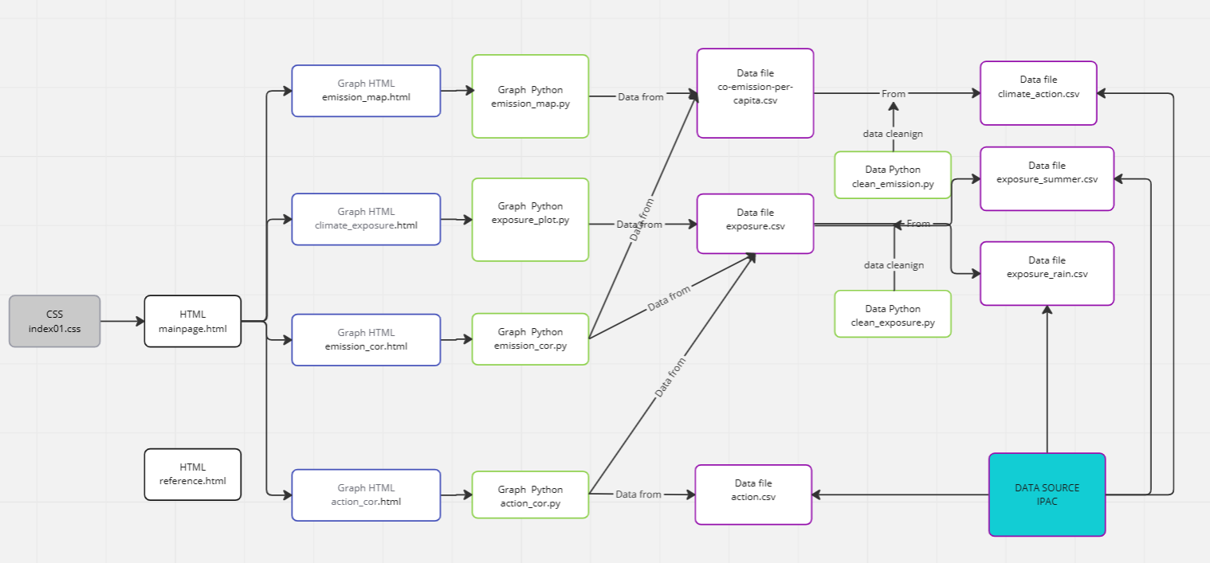

**Reference(Also at the footnote of the website)**

**Data source:**

**<https://www.oecd.org/climate-action/ipac/dashboard>**

**Video source:**

**<https://www.youtube.com/watch?v=QQYgCxu988s&t=44s>**

## **Image**

https://www.theguardian.com/environment/2014/sep/16/climate-change-report-damage-overhaul-global-economy

https://www.exeter.ac.uk/internationalsummerschool/programmes/pathways/climatechange/

https://www.theguardian.com/world/2015/feb/07/climate-change-marchers-private-security-protest-police

https://centreforaviation.com/analysis/reports/climate-change-its-impact-on-aviation-the-time-to-plan-is-now-454475

## **Text**

https://unfccc.int/news/halving-emissions-by-2030-is-new-normal-race-to-zero-anniversary

https://www.epa.gov/climatechange-science/impacts-climate-change

https://www.who.int/news-room/fact-sheets/detail/climate-change-and-health